Upper Stony Creek Transformation project update

November 2019

Melbourne Water is committed to enhancing life and liveability and creating vibrant green spaces for our community.
In 2016, we partnered with a number of government and industry organisations to fully-fund the “Upper Stony Creek Transformation Project” aimed at revitalising a stretch of the creek for Sunshine North residents to enjoy for years to come.
Works began on the project in April 2018 but unfortunately, large quantities of asbestos were discovered during the wetland excavation works. Due to the increased costs associated with the removal of this asbestos, the project was put on hold to determine the most appropriate way forward for the project.

What’s happening?
All Project Partners remain committed to together delivering an excellent and innovative outcome that addresses the complexities of the site that have arisen since the original design and have already undertaken significant remediation works and ensured the site is safe.
We are committed to achieving the health and wellbeing benefits the project aimed to bring to the local community and environment and will continue to work with delivery partners to secure the additional funding required.
Following the discovery of this extensive asbestos contamination, we are also developing a Sustainable Management Plan for the Upper Stony Creek Transformation Project site to ensure community safety and to explore potential opportunities to improve amenity and liveability.

Will the project be delivered in the future?
We aim to leave the site better than before! We already have some ideas for the area such as creating an area for relaxation and reflection, linking with shared path networks that integrate with existing nearby open space and revegetation of the area with native plants and trees. Remediation has been completed on the southern end of the site, including the wetland area, and work will soon recommence on completing these components.
In the northern section (Furlong Rd end), we will use a mesh barrier topped with clean top-soil to ‘cap’ asbestos below ground and then undertake landscaping of the northern (800m) section of the channel to include undulations, grasses, bushes and occasional trees improving natural habitat and amenity (see preliminary plan overleaf). This plan is preliminary and will be finalised following community and stakeholder consultation and further technical investigations.
We are keen to hear from local residents on your ideas for improvements that will complement the passive recreational values of the space and we invite you to contribute at our community pop-up to be held on Thursday 28 November from 4pm – 7pm at the Gilmour Road end of the site.
The partners continue to pursue further funding to enable us to achieve the original vision of the Upper Stony Creek Transformation project. We look forward to continuing to work with all stakeholders to deliver the best possible outcome for the community.

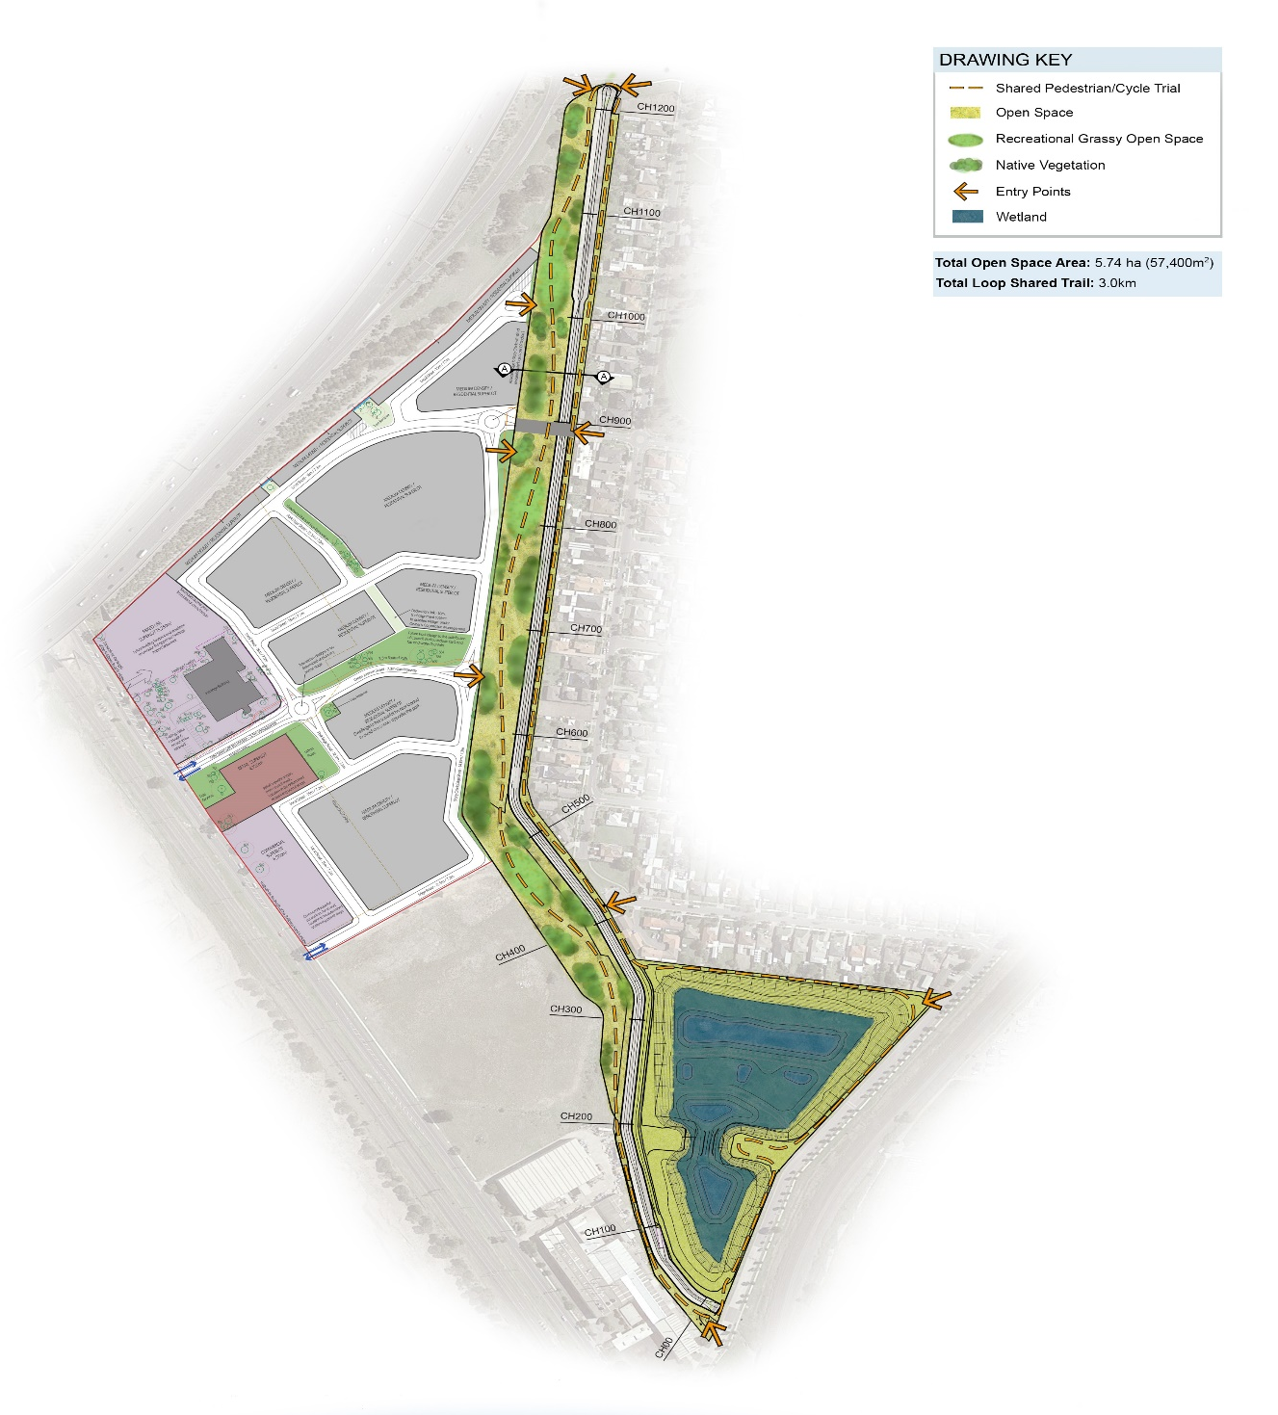
Preliminary site plan
Artists impression of future site, for indicative purposes only
Keep up to date with what’s happening
For more information about this project or our other activities please call 131 722 or visit www.melbournewater.com. For an interpreter, please call the Translating and Interpreting Service (TIS National) on 13 14 50.

